Contents

Introduction 1

Initial Thoughts 2

Proposal 2

Requirements 3

Data Requirements 3

Design 4

Automated testing 4

Sprint 1 5

Sprint 2 7

Sprint 3 9

Review Of Product 11

Improvements 11

# Introduction

A company (Toka Fitness) has asked me to develop a digital solution for them,

Toka Fitness is a fitness company that wants to improve customer interactions and have a better user experience.

Toka currently provides their customers with:

* Personal training sessions
* Advice about fitness training
* Advice about healthy living

Toka Fitness would like me to implement and develop a solution that will:

* Provide information and advice about fitness training and healthy living
* Provide access to a digital content to support customers with their training and healthy lifestyle
* Encourage existing customers to use more of the services already provided by Toka Fitness.

The client has carried out some research with some of their existing customers and to find identify features that could be included in the digital solution, the potential features suggested by the existing customers are:

* Free and paid content
* Accessibility features for users with sight loss
* Social features (such as a forum)
* Customisable workout and eating plans

# Initial Thoughts

My initial thoughts for develop the digital solution and meeting all the requirements is to develop a webserver, capable of creating a user and storing it in a database.

I will also be planning to add a navigation bar to the webserver that will link to other aspects of the page such as to a food plan or to a forum page for ease of access.

I will be planning to use **HTML** to create the webserver to add some dynamic features to the page such as parallax text I will be implementing some JavaScript into it.

I will also be using **CSS** which is a stylesheet (to make the page look nice), I intend to utilise **PHP** to create a forum page where users can leave comments about fitness and talk about their progression.

To store user accounts, I plan to use **SQL** which is a database software.

# Proposal

My proposal for the digital solution that Toka Fitness has asked me to design will be to create a website that will allow the user to create and account to access the website further. There will be a free account that will be able to access some of the lower tier content of the website, and a premium account (paid) which will have full access to the website such as access to customisable workout and eating plans and much more.

* To make the website I will be coding in HTML and JavaScript to implement some dynamic features on the page.
* In further sprints I may change the design of the website, however I will most likely be adding more features to the page, such as parallax text, drop down boxes and much more.

When creating an account, I will be using mySQL to store the account details on a database where it will be easily accessible and secured.

* Using SQL and maybe a little bit of python I should be able to communicate from the database to the webserver and vice versa.
* By storing the user’s data in a database, it means I will be able to easily call it when a user tries to login.
  + I also must make sure that only the correct people can view the database if not I could be at risk of a data leak and faces legal actions from DPGR.

I also plan to add a social tab/forum page to the website allowing users to write reviews and communicate with each about how they are getting on with their goals and to discuss their frustrations and how to improve and reach new goals.

* To make the forum page I will be using PHP to make and design the page.

Using PHP, I should be able to have customers interact and leave comments on the page whilst keeping a neat and modern design.

I will be using XAMPP control panel to host the server locally, this will be used later on to link my PHP scripts to my database that will need creating.

Without XAMPP the script will not work. This will be very crucial when doing my login/register pages and they will heavily utilise php and the database to store the information.

# Requirements

**Functional Requirements:**

* Create useable website
* Data is stored in database once user is created
* Premium members will have access to forum page and be able to leave comments
* Data is stored in database once user is created

**Justification**

|  |  |  |
| --- | --- | --- |
| **Requirements** | **How will I accomplish** | **Acceptance** |
| **Create useable website** | **Using HTML and JavaScript I will make a website** | **When I click load on the website it will open and allow me to access the website as a whole** |

**Non-Functional Requirements:**

* The program can run.
* The program loads every time.
* Updated quickly.
* The program runs effectively.
* It performs well under stress.
* Updated security to protect users.
* No bugs/errors or very little on release.

# Data Requirements

The following data types will be used:

• Strings: used to store information such as login credentials, passwords, emails, and other text-related data.

• Floats: utilised to store decimal numbers, such as cash, because they are not whole numbers.

• Boolean: true or false to allow data to flow in and out at different times. Incorrect passwords, for example.

# Design

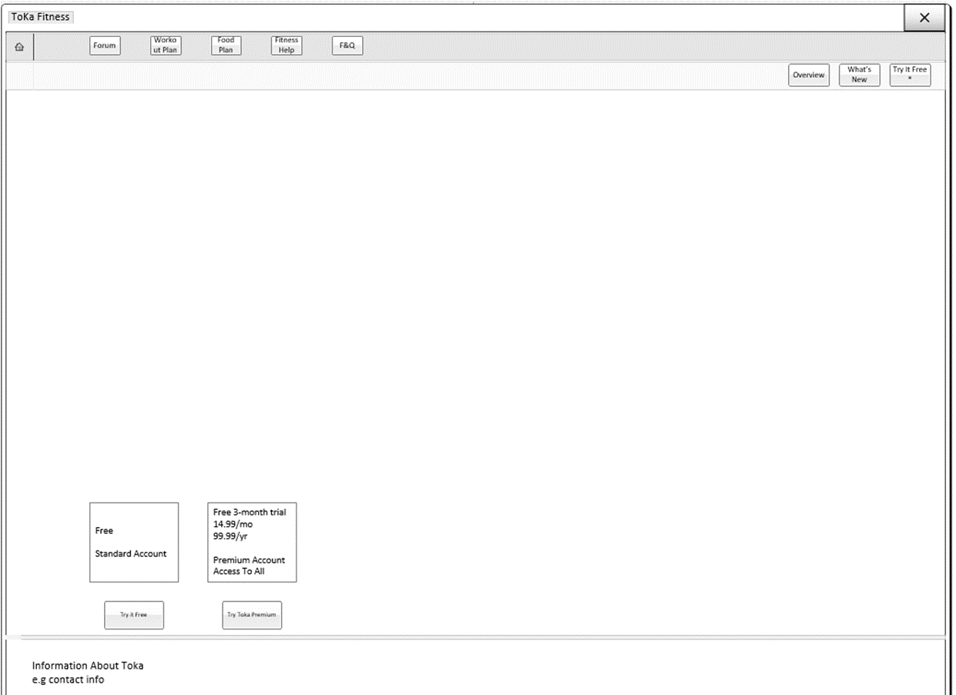

ww

# Automated testing

Real users and manual testing aren't usually required. Stability and non-regression tests, as well as those performed with each new feature or modification, are examples of repetitive tests that can be automated.

* Reduce costs by lowering the amount of work that must be done manually.
* Make the most of your testing efforts.
* With a simple click, you can run dozens of tests to increase your coverage.

# Sprint 1

[basic function]

**Design**

For my design of the landing page of my website I wanted to go for a clean and modern approach, for my inspiration I have looked at apples fitness website and implemented some of their aspects into mine.

Sprint 1 is all about creating the basic functions of the website, meaning I will be needing to code the bare minimum functions as I will be developing them at a later stage.

For my colour scheme I will be going for a white and green theme. For the green I would want it quite bright as green is a colour related to health and success.

**Development**

When developing the landing page, I will be using HTML, CSS and some JavaScript.

This is the design and features I managed to come up with for sprint 1.

The heart in the top left will act as the home button and is also the logo of the client.

The heart will feature on all of the pages and will always take you to the main landing page to keep ease of access high.

I have added a small downwards arrow to the bottom of the page, this will help users to see that there is more information below.

The navigation bar can be found at the top of the page and will remain there as you scroll further down the page.

For my navigation bar I went for a simple and transparent design to keep the rest of the page looking professional, when clicking on the links within the navigation bar it will take you to the corresponding pages.

I am happy with the overall layout however in later sprints it may be changed slightly to fit any further needs.

The profile button has been splint allowing some extra padding for the arrow on the side. Once clicked the dropdown menu will appear taking you to user logon and register pages.

Once expanded the user can find 2 more links to create and account or to login to an already existing one.

**Review**

Overall, I am very happy how sprint 1 came out, the clean and sleek design of the landing page is simple yet eye-catching. I still plan to add a background image but still have not decided on what I would want.

I also think I could have improved the main heading of the page, as it does look a little basic even for sprint 1.

# Sprint 2

**Design**

Originally, I was going to have 2 navigation bars but then decided to change back to one as the second one looked out of place

For my next sprint I will be attempting to add some parallax text to the lower half of the page, this will help to bring some much-needed dynamic aspects of the page.

When you scroll down the page the text should fade in and fade out.

**Development**

For sprint 2 I have incorporated some parallax text which hopefully will improve the users visit and will keep their attention for longer.

For the parallax text I was inspired by the apple fitness webpage, as they have a similar layout and design.

<https://www.apple.com/uk/apple-fitness-plus/>

The text will fade in and fade out when scrolling through the page.

I have also included a place to register and understand the benefits that each user account has below.

**Review**

Overall, I am happy how sprint 2 has came out, the use of the parallax text will increase user interactions and keep their attention whilst navigating the rest of the page.

By having 2 places where you can create an account will hopefully increase the number of accounts created as sometimes it can be difficult to find where to make an account as some users may not know that the dropdown box can open so they can find the profile links.

# Sprint 3

**Design**

Sprint 3 will be about designing the login and registration webpages, for this I will be using some HTLM, PHP and mySQL.

I will be using mySQL to store the user’s information in a database so they can be called later on when a user is logging in or if a user has entered a email address that has already been used when creating an account.

**Development**

This is what I have come up with for the registration page,

The registration page consists of 4 data forms that require a user input to fill out to create their account.

I have added a confirm password form, to ensure that the user has entered the right password. To do this I used PHP.

When creating an account, the system will check to see if an email address has already been used, this will help nullify a user having multiple accounts under the same email address.

One you have filled out all your credentials, pressing the submit button will utilise my php script to store all the user’s information into the database that I have created, and put the information into the right column.

Attempting to put an incorrect email will warn you and stop you from pressing the submit button.

Thus, stopping any incorrect information entering the database.

By using PHP, I am also ensuring that any attempts for SQL injections are nullified

This is my final design of the login system.

When entering your credentials, the system will check if the account exists and will login you in, however if the system cannot find an existing account it will display that the account cannot be found.

**Review**

Overall, I am very happy of the layout of sprint 3, when entering creating a user the information will be stored into the database that I have created, to link the database to the form I used PHP.

One thing I would change is the padding around submit and the password form as it is currently flush, and I personally think it would look much better if there was some padding.

# Review Of Product

For my final project I feel like I have done good, as it is all functional and has met the user and client’s needs.

The overall deign of the product is very sleek and modern, I could have used some more colours such as green to give a livelier and healthier atmosphere to the pages.

# Improvements

If I had more time, I would have implemented a forum page utilising PHP.

I also wish I had designed a background for the page that would change the image every time you refresh the page, however I couldn’t figure out how I would do it as I am still learning how to do some things or to fit it in the time frame given.

Better time management would have been another great thing, as I found my self having to cram everything in since I had very little experience with PHP and mySQL so having to learn how to code and utilise everything they offer was very time restricting.

Next time I will use a ghant chart to keep on top of my time management.

For time management with sprints, I could use a ticket system, where I would write everything I wanted to get done and work on them one by one.

Another thing that could have improved the project would have been to stay in touch with the client, as it is always good to stay in communication with the person you are doing the project for, as they could have had a different idea or a new feature that they would like to see implemented in the project.